Table of Contents
- Luxury Environment – Natalie Duminiak
- Narrative Overview – Natalie Duminiak
- Table of Symbols & Meaning – Elle Walasavage
- Art – Elle Walasavage
- Anti-Laws – Maggie Wise
- History & Rarity – Maggie Wise
- Localization – Molly Shull
- Brand Identity – Molly Shull
- Products – Mattie Lugar
- Conclusion – Mattie Lugar

- Luxury Environment
Product Topology
Valentino’s website organizes their products into the following categories: Sale, New Arrivals, Rockstud, Women, Men, Bags, Gifts, Beauty, and V-Universe. From there, our group chose to focus on looking at the category of “Women,” as that is where their signature products and styles are mostly at. Valentino’s signature styles include the well-known “Valentino Red” dresses, along with dresses focused on the feminine form through the additions of lace, chiffon, bows, and ruffles. In selecting a signature dress to compare across other luxury brands, we chose Valentino’s Cady Couture Long Dress with Feathers because it displays the elegance of the brand and is one of their more expensive pieces. The category of “Women” is further divided into the subcategories of New Arrivals, Ready to Wear, Bags, Shoes, Accessories and Must Haves. The price range and total number of items in each category is listed below. The number of 345 in the Ready to Wear category is the number when excluding the New Arrivals items that also ended up in the Ready to Wear category. The -65 in the Accessories category is due to Accessories including purses and wallets, along with a bunch of other things. And we realized upon further research that Must Haves wasn’t a particularly meaningful category, so we removed it from our research.
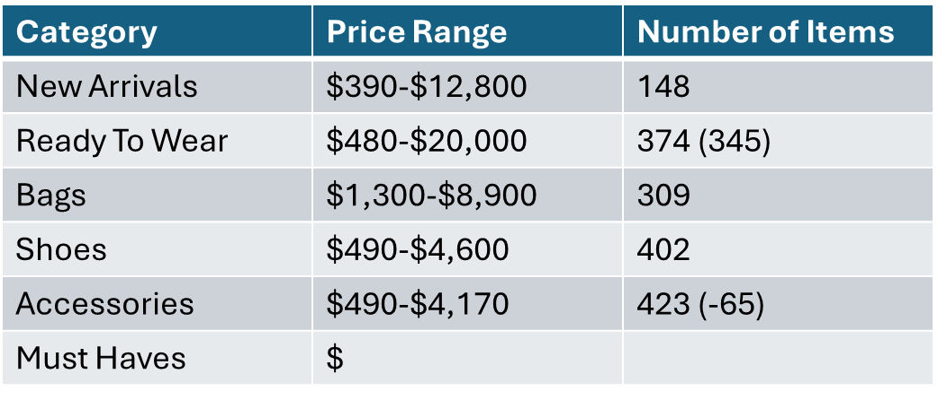
When looking at this chart, we saw that the product category of Ready to Wear is the most expensive category. This makes sense, as their signature product is featured in this category, and their more special pieces are expected to be on the more expensive side. We also noticed that the category of New Arrivals has the lowest entry-level price, and that Valentino sells less attire than accessories, with the New Arrivals category including everything (bags, shoes, clothes).
Product Price Across the Fashion Sector
- Valentino: Cady Couture Long Dress with Feathers)
  - Cost: $14,000
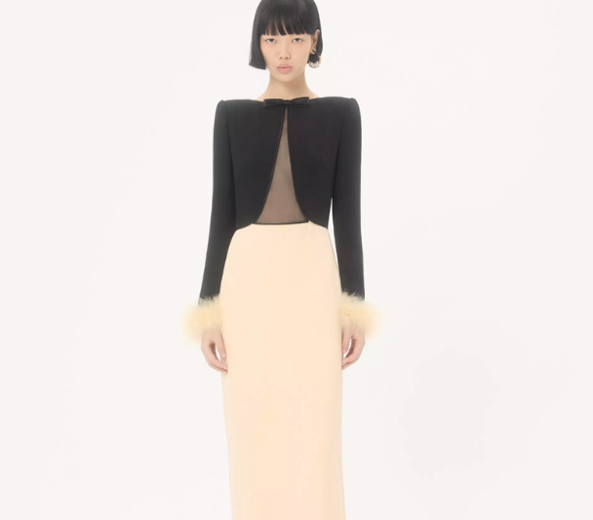
- Comparable products for other luxury brands across the fashion sector:
- Gucci: Printed Silk Chiffon Dress
  - Cost: $16,000
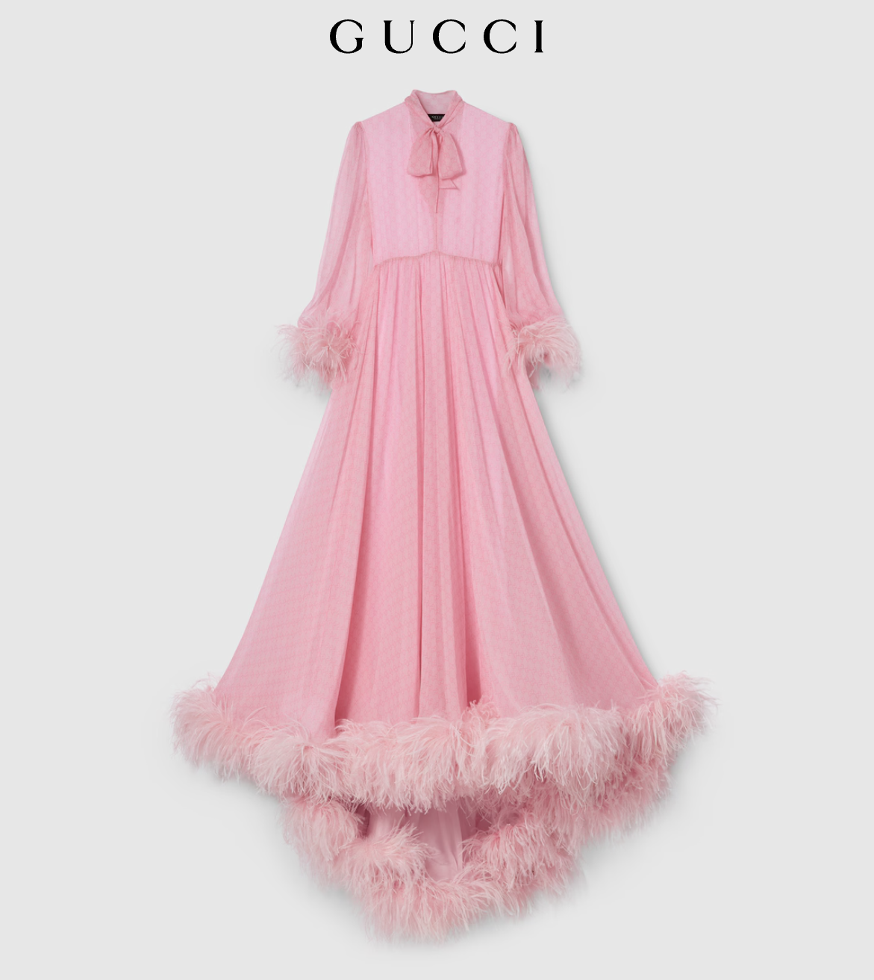
- Versace: Envers Satin Crepe Draped Gown
  - Cost: $4,390
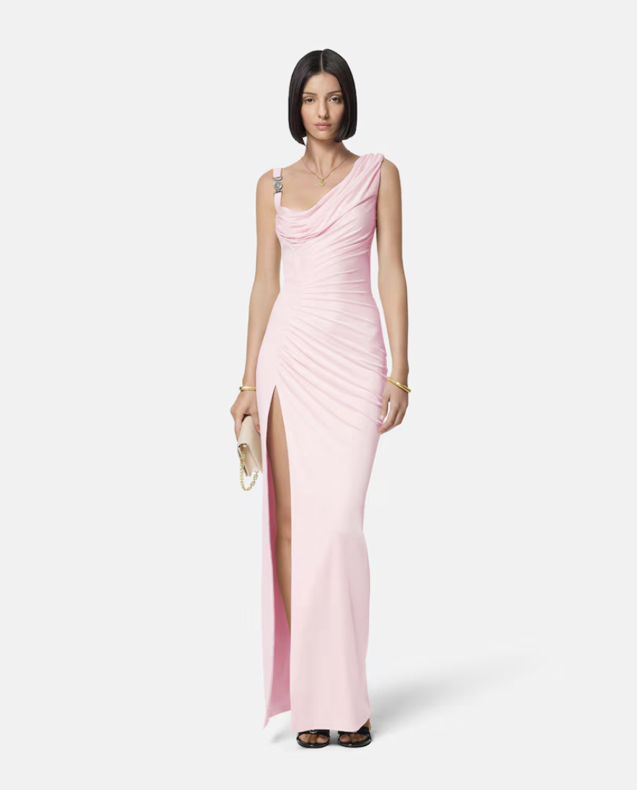
- Chanel: Embellished Cut-Out Plunging Open Back Evening Dress Gown
  - Cost: $6,800
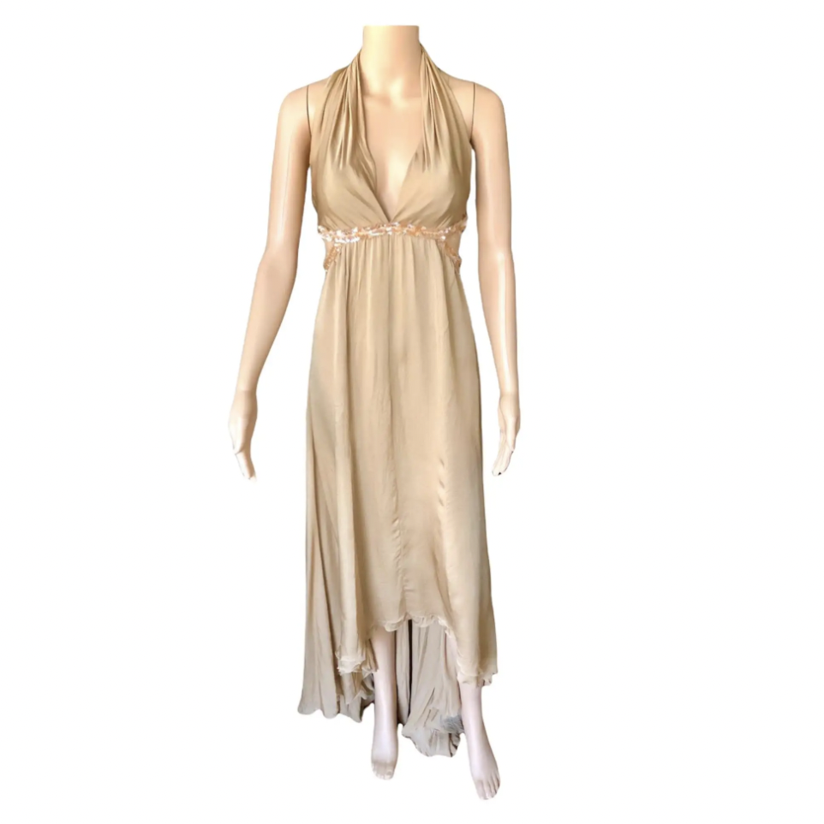
- Dolce & Gabbana: Open Back Lace Gown
  - Cost: $12,200
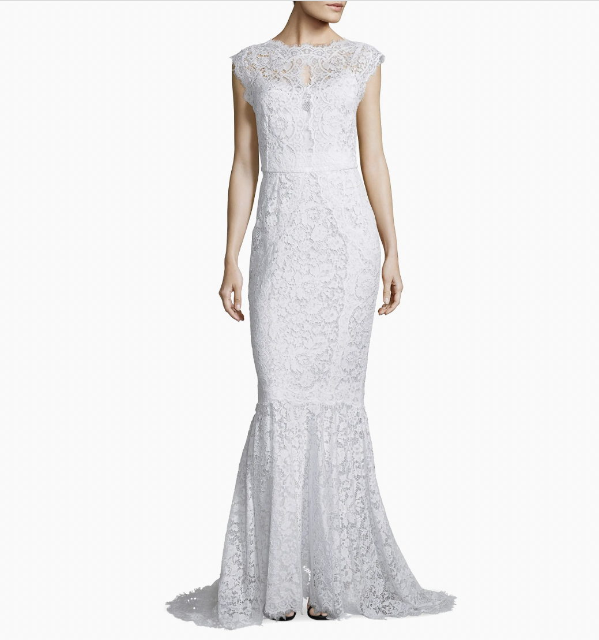
- Dior: Black Velvet Long Dress
  - Cost: $8,631.47
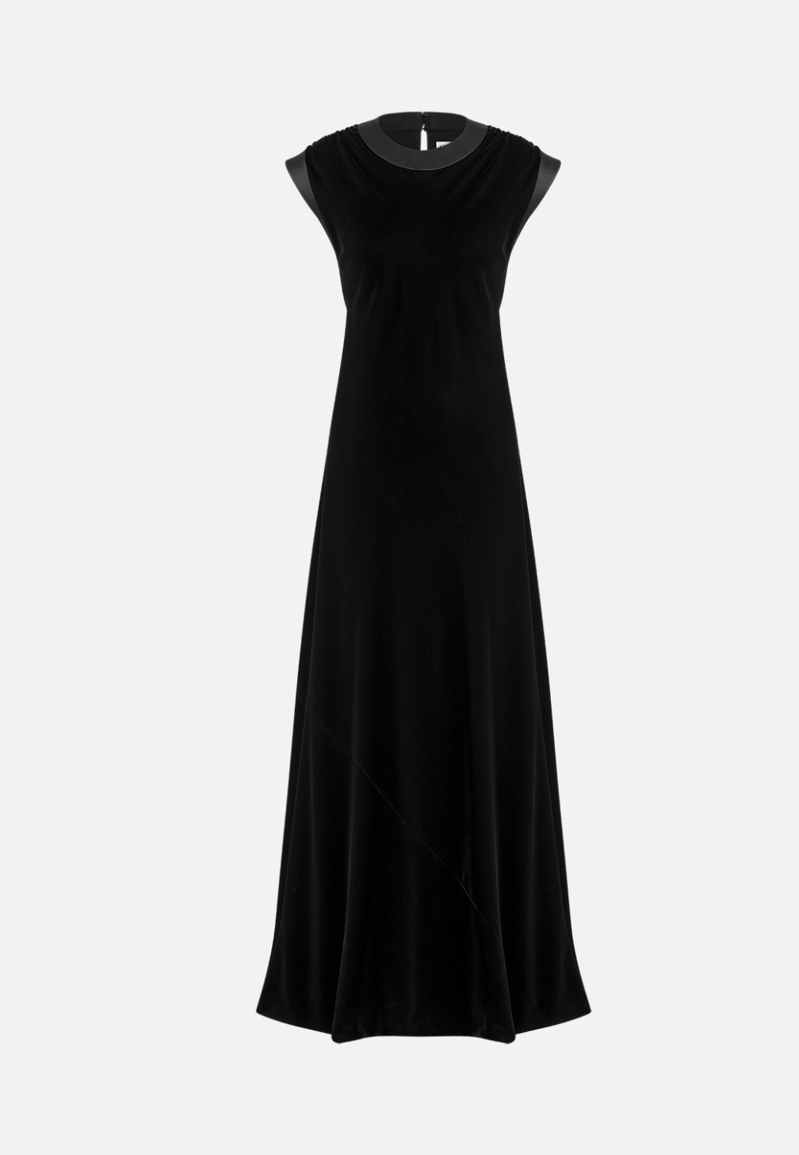
- Prada: Long Chiffon Dress
  - Cost: $8,800

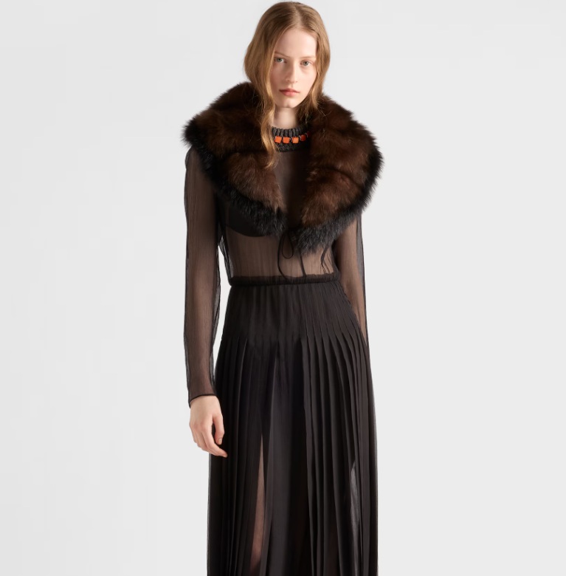
- Burberry: Belted Check Wool Dress
  - Cost: $2,295
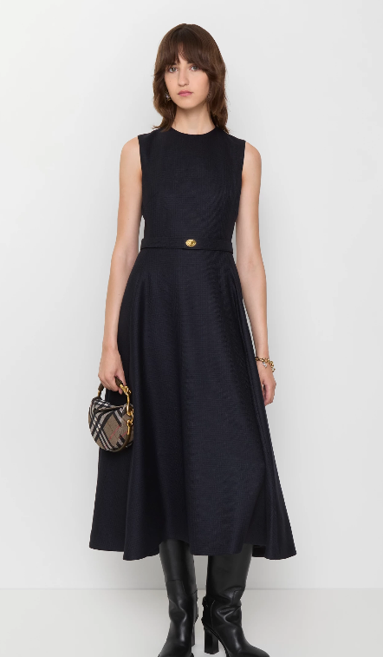
- Balenciaga: Off-Shoulder Maxi Dress
  - Cost: $3,150
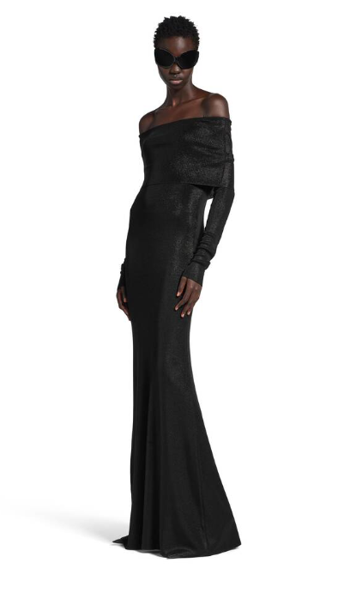
- Armani: Long Dress in Embroidered Silk
  - Cost: $37,000
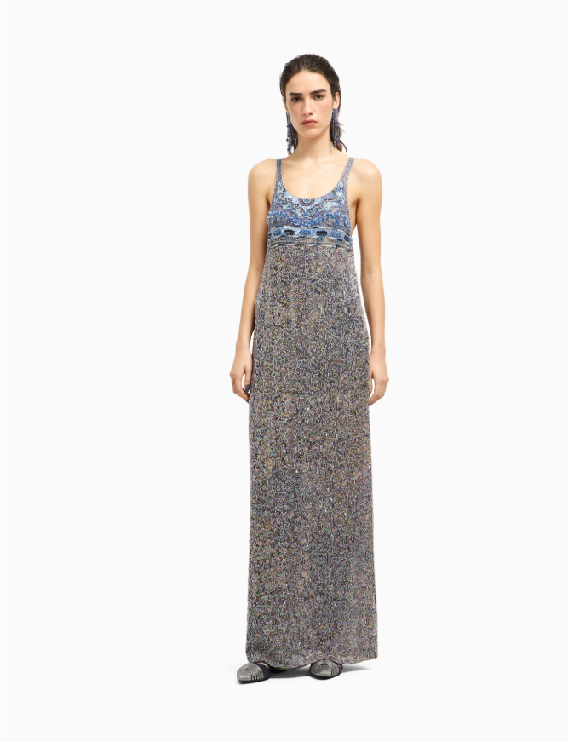
Product Availability Across the Fashion Sector
- We selected New York City as our location to measure availability because it is a large city that has multiple stores for every brand we’ve looked at in the fashion sector.
  - Valentino: 9
  - Gucci: 8
  - Versace: 2
  - Chanel:16
  - Dolce & Gabbana:12
  - Dior: 8
  - Prada: 5
  - Burberry: 4
  - Balenciaga: 3
  - Armani: 17
  - YSL: 5
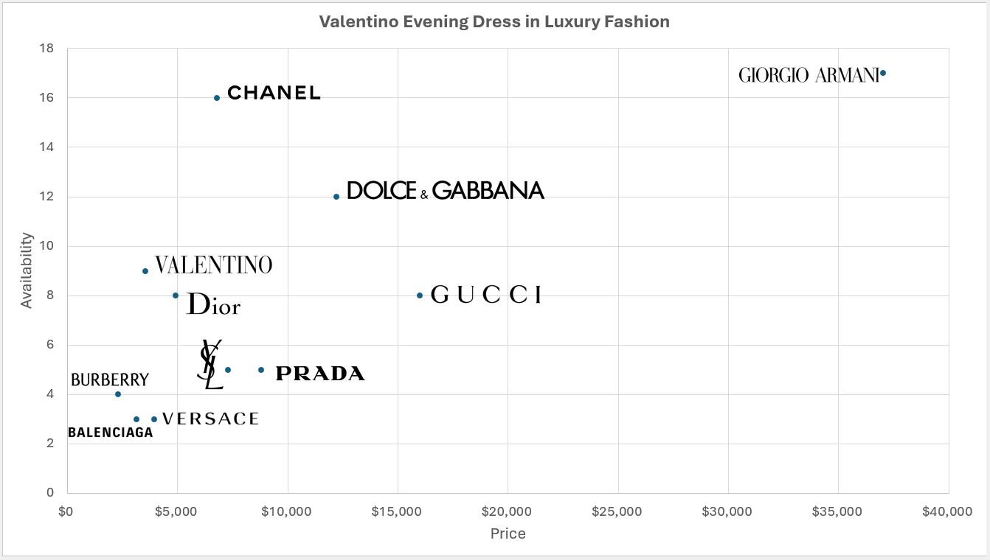
Scatterplot Discussion
The distribution does not follow along the lines that we would expect regarding evening gowns/dresses in the luxury fashion sector. Generally, we would assume that high price means low availability and vice versa; that low price means high availability. However, when looking at the extreme ends of the spectrum, it’s seen that Burberry, Balenciaga, Versace have lower prices and lower availability for their evening gowns/dresses, and Armani has both a much higher price and much higher availability in comparison to the rest. The Valentino couture evening gown does follow what we would expect though, lying in the middle of the distribution.
- Narrative Overview
Creators, founding myth & legend
Valentino was created by Valentino Garavani and Giancarlo Giammetti. The founding story goes that in 1959, Valentino, passionate for art and fashion, moved to Paris at age 17 to study at the Ecole de la Chambre Syndicale de la Couture. That same year, he debuted his first Haute Couture collection, “Ibis.” Then, in 1960, Valentino met Giancarlo Giammetti, an architecture student from Rome. In that same year, Maison Valentino was founded by the two of them. They ran it together as partners until early 2008, with Giammetti managing the business side while Valentino focused on design.
Holy Land
The holy land for Valentino is its originating location in Rome, Italy. This holy land is still shown through its social media pages, on their fragrances that still state “Born in Roma” on their packaging, and through their fashion events, many of which taking place in Rome, Italy.
Sacred Icons
Many sacred icons exist for Valentino in both cultural symbols and creative directors. Some of Valentino’s cultural symbols are Elizabeth Taylor, who was Valentino’s first major famous client, Jacqueline Kennedy and the Valentino wedding dress she wore for her 1968 wedding to Aristotle Onassis, as well as Julia Roberts and the Valentino dress she wore when winning Best Actress Oscar in 2001. Valentino’s creative directors (who also served as sacred icons) are Alessandro Michele (2024 – current) and Pierpaolo Piccioli (2008 – 2024).
Cathedrals – Flagship stores
Valentino’s most iconic store is Valentino Via Montenapoleone, which is located in Italy. Their newest store is Valentino 654 Madison Ave located in New York, NY, which opened in November 2023.
Sacrifice
Valentino also demonstrates sacrifice through their most hard-to-find items: haute couture fragrances. Released last year, they are collection of perfumes named “Anatomy of Dreams,” featuring seven scents formulated by a variety of perfumers across fragrance houses.

- Table of Symbols & Meaning
Symbol | Name | Meaning | Importance
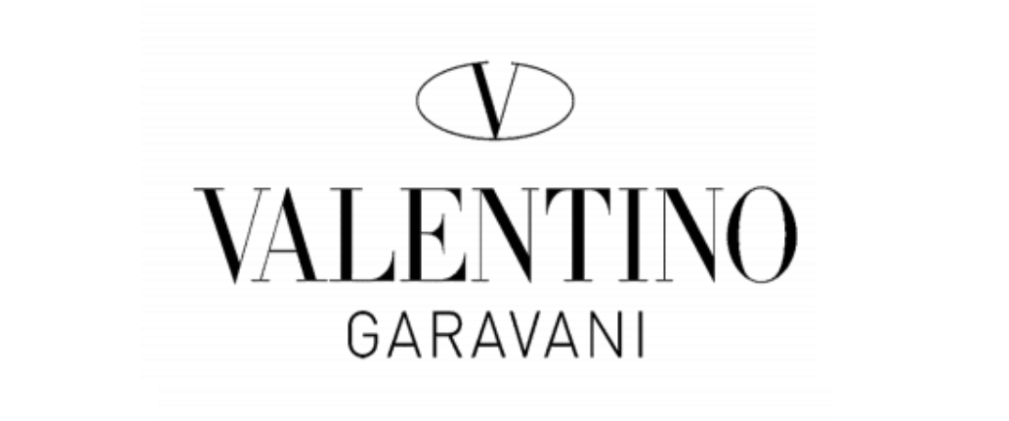 | Valentino Garavani V-Logo (1960-1979) | Represents Valentino Garavani’s personal identity. Conveys themes of elegance and high-end luxury through a simple yet effective logo cementing Valentino’s presence in the market. | The initial logo was the only one to include the creator's last name. It showcases refinement of the creators personalized signature, setting the tone for the brand and distinguishing them from others.
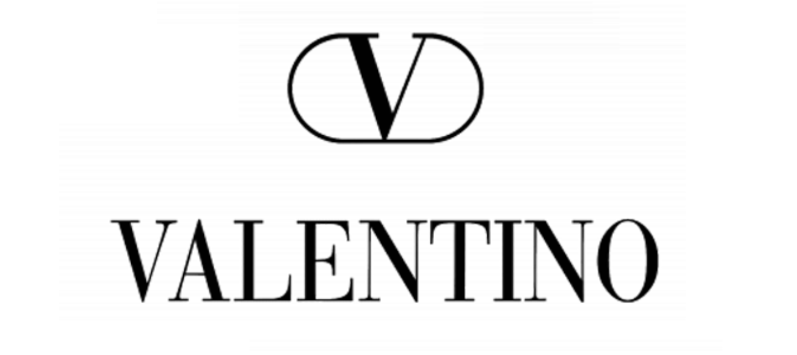 | V-Logo Signature (1979-Today) | This logo served as a bolder, modern interpretation of the original “V”. It was built for contemporary appeal to portray the brand's evolution over time. | Valentino transformed the original logo into a modern version for greater visibility. A simple and clean approach that allows them to stay relevant while maintaining a connection to their history of success.
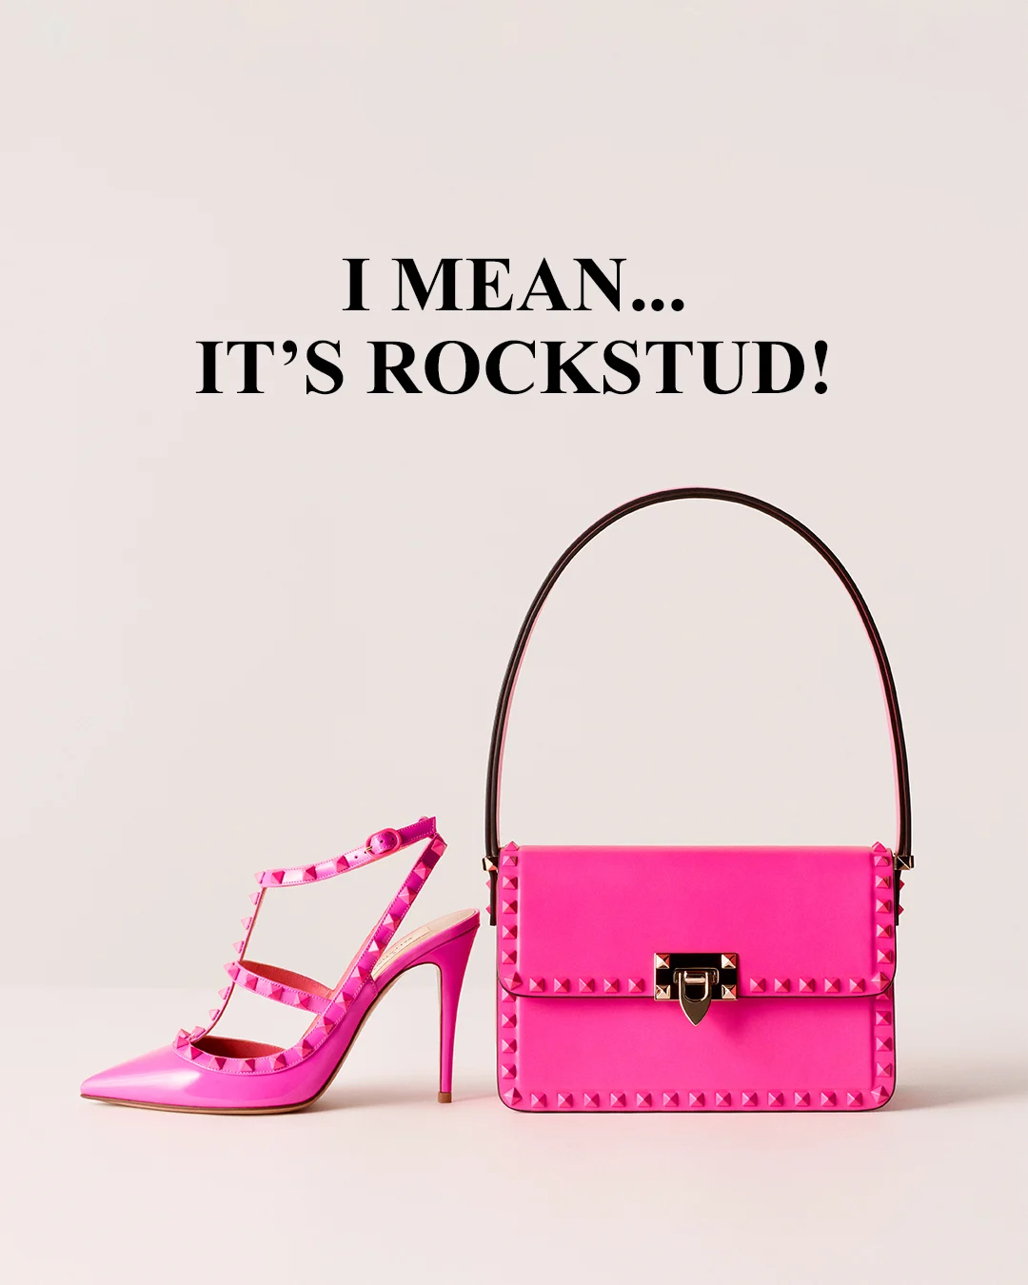 | Valentino Garavani Rockstud Motif | Unique pyramid shaped studs that symbolize boldness and strength. Found mainly on purses and shoes, this motif allows Valentino to appear edgy yet sophisticated. | Became an iconic design for Valentino accessories, connecting the brand to younger audiences and helping them stand out in the progressing world of fashion.
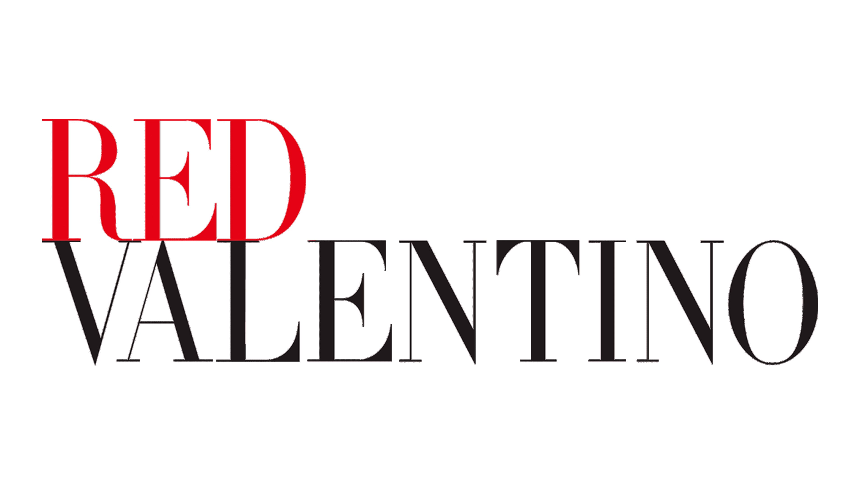 | Valentino Red | The signature Valentino Red color serves as a symbol of beauty, passion, and romance. Valentino believed a woman in red was the “perfect heroine”. | The color appears in almost every Valentino collection as a symbol of status. This iconic red is a visual identifier of the brand and reinforces prestige.
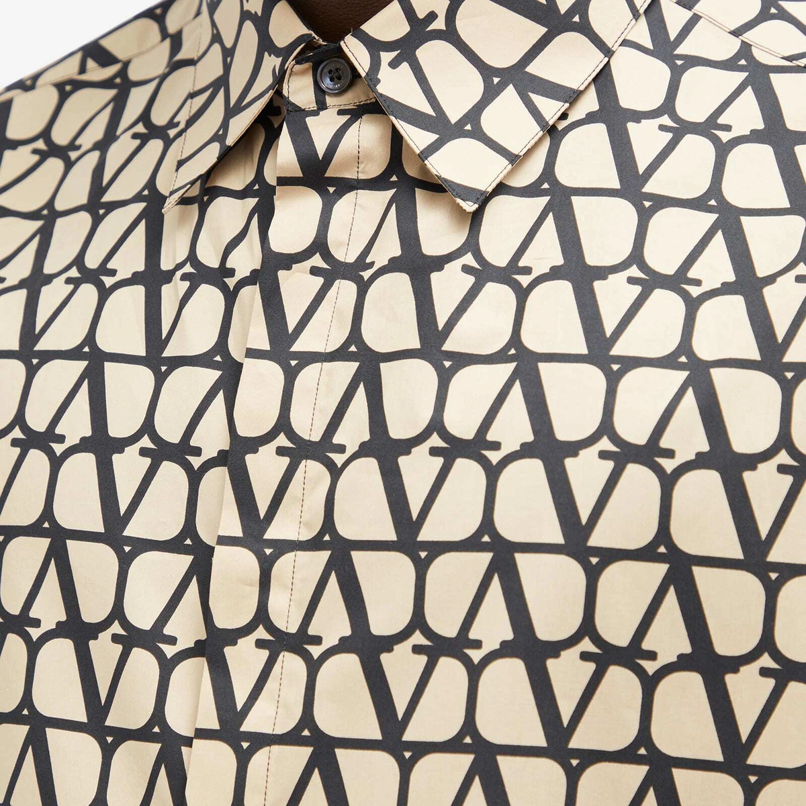 | Valentino Monogram Pattern | The repeating “V” monogram pattern used on accessories highlights a unique form of brand recognition. | The pattern strengthens consistency, tying the identifiable Valentino V logo into current products, enhancing heritage and visibility.

Collaboration With Art
The use of art within luxury is crucial for shaping the identity and presence of brands. Through the association with beloved art forms, iconic brands like Valentino can present a sense of creativity and exclusivity that goes beyond simply the use of the products they offer. Key partnerships with artists combined with music, dance, and paintings signal a refined relationship between the heritage of luxury brands and art itself. Using art to enhance brand specific values and culture cultivates an emotional connection with audiences, setting them apart from competitors. This way, brands can create a distinct aesthetic for themselves. Art is more than just a symbol or decoration; it is essential for storytelling.
- Anish Kapoor: Valentino partnered with Anish Kapoor to further their expansion into art through the Valentino Garavani Foundation. This helped enhance Kapoor’s reputation and connection to Valentino’s focus on emotion, bold colors, and sculptural design. Association with a unique, respected contemporary artist strengthens symbolic value, positioning the brand to reflect an emphasis of experience over product functionality.
  - Anish Kapoor is a British contemporary artist known for his work in conceptual art, installation art, and sculpture. Since the 1980s, he has received multiple prestigious awards and honors including the Premio Duemila Prize at the 44th Venice Biennale in 1990 and the Turner Prize in 1991. Kapoor became known for his explorations of matter and non-matter, and after 1995, he gained widespread recognition for his innovative use of stainless steel. One of his most famous works is Cloud Gate ("the Bean") in Chicago.
  - Valentino partnered with Anish Kapoor to create an immersive exhibition exploring the color red as a symbol of the brand’s identity.
  - The launch of PM23 cultural space occurred in May of 2025.
  - PM23 (Palazzo Mignanelli 23) is a restored cultural space in Rome, Italy.
  - This collaboration is an example of Valentino acting as a patron of the arts. Valentino supported Anish Kapoor through the Valentino Garavani Foundation and provided the artist with a dedicated space to create an immersive exhibition. Within this partnership, the brand provided Kapoor with the necessary platform, materials, and resources to launch the PM23 cultural space. Rather than simply seeking legitimacy, Valentino invested in the necessities of the artist to generate an influential way for the brand to actively indulge in art while maintaining their role in the luxury industry.
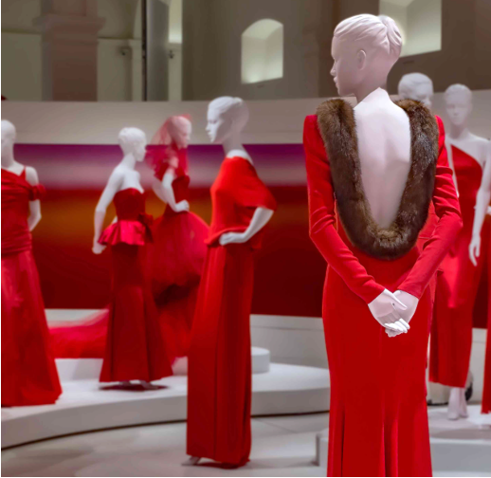
- Roger Dean: Roger Dean and Valentino partnered for the 2020 Summer collection to embrace a fantasy-inspired theme centered around the concepts of individuality and imagination. Valentino used Dean’s iconic artwork as the blueprint for the designs. This helped to enhance Valentino’s association with popular culture and reinforce an emphasis on self-expression. This collaboration was a way for Valentino to blend their sophistication alongside fascination.
  - Roger Dean is an English artist known for his fantasy-inspired album cover designs. He graduated from the Royal College of Art and is recognized for his influential typography (notably from Osibisa’s first album) and as being the co-founder of the publishing companies Dragons’ Dream and Paper Tiger.
  - Roger Dean collaborated with Valentino on a Summer Menswear Collection, incorporating his iconic artwork for creative storytelling. The collection was designed by Italian designer Pierpaulo Piccoli, with ideals of freedom and character. This show was dedicated to "dreamers, romantics, idealists, and other masters of imaginary worlds." It started as a mental escape for customers to dive deep within themselves. Dean's artwork acted as the basis for the rest of the collection with vibrant embroidery accentuating the pieces.
  - This occurred in 2020 for the Summer Menswear Collection.
  - This collaboration was presented as part of Valentino’s menswear collection (runway and campaign platforms).
  - The work between Valentino and Roger Dean is an example of the brand acting as a patron of the arts. In this collaboration, Valentino used the 2020 Summer Menswear Collection as a platform for Dean to translate his artistic visions into iconic Valentino fashion products. Rather than using his reputation for legitimacy, Valentino invested in Dean’s originality to shape the aesthetic of the collection. In doing this, the brand allowed Dean to be supported financially and professionally, using this collaboration to not only enhance his credibility as an artist but to reinforce Valentino’s distinctiveness as a brand.
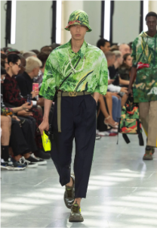

- Chloe Leong: Valentino’s L’École collection focused on performance over normal runway methods, using dance to express the brand’s identity and emotional depth. Chloe Leong is an experienced contemporary choreographer, and she joined the brand to create a cultural narrative expressed through movement. The performances took place in unconventional places, with the artists wearing Valentino products from the collection. This helped make high-end fashion more accessible to the public. The collaboration enhanced Valentino’s association with the arts while highlighting luxury’s focus on immersive experiences.
  - Chloe Leong is an Australian choreographer, movement director, and dancer who started her journey at the Rambert School of Ballet and Contemporary Dance in London, where she earned a 1st class BA Honors degree. After graduation, Leong danced with IT Dansa in Barcelona, performing contemporary repertoire and expanding her abilities with diverse choreographic styles. She later joined the Sydney Dance Company where she began choreographing and received the Helpmann Award for 'Best Female Dancer' in 2015 for her portrayal in 'Quintett' by William Forsythe. Leong was also the co-director of contemporary dance collective NEW OLD NOW (NON), supporting innovative performance projects and emerging artists.
  - Valentino collaborated with Chloe Leong to produce the L’École with a performance piece titled Skin Deep. The performance was inspired by the Spring/Summer 2024 collection, highlighting themes of femininity, the human body, strength, and softness. Instead of using a traditional runway fashion to showcase the collection, it was presented through dance and movement. Dancers filled everyday places and streets, performing in the designs throughout the event. The choreography was inspired by the original runway show where the collection debuted.
  - The performance took place in public areas around Sydney, Australia. This allowed everyday people to be impacted by the touch of the brand, not just those who have access to traditional fashion spaces. This increased interest, desire, and presence within the arts for Valentino amongst various consumers.
  - This performance occurred in March of 2024 and marked Valentino’s first arts-led project created in Australia.
  - Chloe Leong’s collaboration with Valentino helps lend the brand legitimacy. Chloe Leong is a respected and experienced dancer, choreographer, and performer. Partnering with a well-known, talented individual allows Valentino to transform this collection into an immersive experience, utilizing her credentials to propel their success. Having dancers present the ‘Skin Deep’ performance within public spaces allows Valentino to use Leong’s presence in the world of dance to uplift their reputation in luxury and connection with the arts. This adds depth to their presence as a brand, building from the appeal of Chloe Leong within this specialized community.
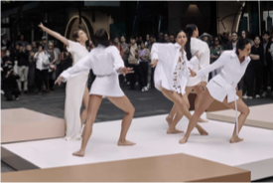
- Mario Schifano: The collaboration between Mario Schifano and Valentino focused mainly on visual art. His large-scale paintings and engaging exhibition helped display his peices to a wider audience. The brand collaborated with Schifano to express their artistic heritage, supporting and showing fine art in a museum style setting. Valentino was able to emphasize the promotion of meaningful works like Schifano’s with their credible foundation.
  - Mario Schifano was an Italian painter known for his Postmodern collages combining advertising imagery, wrapping paper, and painted elements. He worked in numerous areas of media, transitioning between film, music, or photography. Born in Homs, Libya he emigrated with his family to Italy at a young age and was a self-taught artist. Much of his later work referenced earlier periods in Italian art history. He won several awards including the Premio Lissone (Lissone 1961), the Fiorino award, and La Nuova Figurazione (Florence, 1963). He passed away at the age of 63 in Rome, Italy.
  - This collaboration between Schifano and Valentino featured an exhibition of five large-scale paintings.
  - Valentino collaborated with Magazzino Italian Art, a nonprofit museum and research center focused on Italian art based in Cold Spring, New York.
  - They partnered in November of 2023.
  - Valentino’s collaboration with Mario Schifano through the Magazzino Italian Art, is an example of the brand acting as a patron of the art. Valentino supported the paintings by Schifano, by using the non-profit museum and research center to provide visibility helping the works reach wider audiences. Rather than simply working off Schifano’s credibility, the brand invested in necessary resources, supplying the artist with tools to preserve and present his art. This collaboration demonstrates Valentino’s commitment towards building a relationship with the arts, reflecting the brand’s role in continuing their heritage while supporting forms of artistic expression.
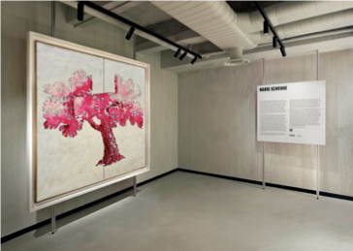
- Giorgio Di Salvo: The collaboration through L’Atelier Sonore between Valentino and Di Salvo focused on creating an innovative experience with sound, architecture, and high-level technology. Di Salvo is known for his work across many art forms, specializing in media, creating a strong addition to Valentino’s creative identity. This partnership included a listening room inside the Madison Avenue boutique, different from Valentino’s traditional presentation forms as an artistic, immersive approach. The room withheld a 10-hour long vinyl program to captivate listeners. The collaboration strengthened Valentino’s relevance, showcasing an experimental take presenting luxury, inspiring artisans to explore new forms of storytelling.
  - Giorgio Di Slavo started his work in the 1990’s deeply rooted in hip hop, later translating to independent work within graphic design and fashion. Di Slavo launched a Milan-based brand called United Standard in 2015, which became a cultural platform for collaboration. He later jumped into the world of music production, multimedia devices, electronics, and sound synthesis. Now, he creates sound objects that are functional and designed forms of technology.
  - Valentino collaborated with Giorgio Di Salvo to create “L’Atelier Sonore”, an immersive listening room in collaboration with Terraforma, turning sound and architecture into one. This experience features forward-thinking artists on vinyl for a 10-hour live program.
  - L'Atelier Sonore is a listening room located on the mezzanine floor of the Valentino Madison Avenue boutique in New York City.
  - The listening room opened on May 15, 2025.
  - The collaboration between Di Salvo and L’Atelier Sonore allows the brand to stay relevant and inspire other luxury artisans. This work focuses on unique architecture, technology, sound, and high-level creativity to create an engaging experience. This pushes the traditional ways luxury works alongside the arts, showcasing an innovative take by Valentino through an unprecedented method. By incorporating the work of a clever artist alongside compelling technological elements, Valentino positions themselves at the head of contemporary art and design. This type of collaboration is so rare and unique; it helps to signal their innovation relevance to both the arts and luxury. The project worked to inspire other artisans, showcasing how luxury brands like Valentino can blend fashion, sound, music, architecture and experimental story telling all in one effort, rather than simply capitalizing on an artist's name.
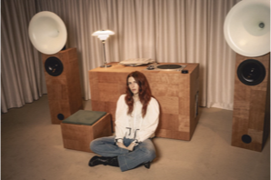
Luxury Brands including Valentino use art to transform their products beyond creating and selling. Art helps to expand the brand's identity, aligning their values with creativity, expansion, and timelessness. The use of art helps to showcase individual brands' culture through collaborations and immersive experiences that reinforce central ideas regarding craftsmanship, exclusivity, and visibility. Art helps Valentino’s work feel more meaningful, instead of just another addition to their product mix.

- Anti-Laws
Anti-laws of luxury marketing are principles that intentionally go against the traditional strategies used in marketing and business logic. Typically, traditional marketing principles have a heavier focus on competition, clear positioning, and affordability to directly persuade consumers to buy their products. Luxury marketing brands instead focus on marketing that emphasizes the brands' exclusivity, storytelling and history, emotional appeal, and its longer-term desirability. Anti-laws in luxury brand marketing allow them to better differentiate themselves by creating a sense of rarity, making the brand feel less accessible to anyone.
The first anti-law used by Valentino is Anti-Law #1: “Forget About Positioning”. This anti-law means that luxury brands like Valentino should avoid positioning themselves directly against their competition by highlighting why they are “better” in a very traditional sense. Instead, these luxury brands should focus more on building a unique identity and universe that exists independently of competitor comparison. An example of Valentino following this anti-law is shown through the AI generated “Valentino Garavani x Vans AI-Generated Campaign”. This campaign truly centers itself around surreal, AI-created visuals that blend the identities of both Valentino and Vans into a more dreamlike digital environment. This campaign focuses on the imaginative and artistic aspects rather than explaining the collab in traditional practical terms. This brand example exemplifies this anti-law because the campaign does not attempt to position Valentino against their competition in any way. It also does not justify the collaboration through its functional aspects but instead focuses on the symbolic and emotional narrative. This reinforces the idea that Valentino can exist in its own creative world rather than just in a competitive market.
An example of an anti-law that Valentino fails to follow is anti-law #16: “Keep Stars Out of Advertising”. Anti-law #16 explains that luxury brands should really avoid relying on the use of celebrities in their marketing because doing so suggests the brand needs to borrow their status instead of using their own status and prestige to be successful. In recent advertisements and campaigns, Valentino has failed to follow this anti-law and as an example in their Fall/Winter 2025 campaign, they featured celebrities like Tate McRae and Dakota Johnson. They placed these celebrities in the center of their campaign visuals, and consumers noticed this collab because of the celebrity's well-known status. This example exemplifies a contradiction of the anti-law because the brand directly centered well-known figures to draw attention to the celebrities themselves, overshadowing the brand. Valentino partially relied on the external fame of celebrities to enhance its appeal rather than relying on the brands' image itself.
Valentino does however follow anti-law #13: “Raise Your Prices Over Time to Increase Demand”. This anti-law explains that for luxury brands it's important to raise prices over time as it helps signal exclusivity, better quality, and a more prestigious status with purchase. This differs from traditional brands as they often lower prices to increase demand and overall accessibility. An example of this for Valentino can be seen through their Rockstud collection. Valentino has increased prices on the products within this line over time, particularly with items like the Rockstud Small Shopper Bag and the Roman Stud handbags. This pricing strategy increases desirability and serves as a long-term brand initiative to reinforce exclusivity through higher price points. This example exemplifies this anti-law as it did not reduce demand for Valentino but just increased desirability over time because consumers associate higher prices with greater rarity in the luxury market.
Anti-law #18: “Do Not Relocate Your Factories” is another example of an anti-law that Valentino follows. This anti-law is used by luxury brands to emphasize the importance of keeping production within the country of origin for the brand. By doing this, luxury brands can promote and preserve their authenticity and heritage, which is important for consumers. Valentino faced challenges with this in 2021 when they faced a factory fire in their shoe production facility in Italy, but still they chose to continue their production in Italy. Thousands of their products were destroyed but instead of relocating completely they used a nearby facility. Valentino had to find a quick solution, and it could have been easier for them to move production abroad, but they decided to preserve their brand identity and quality standards within their home facilities. This exemplifies this anti-law as they preserved their connection to Italian craftsmanship demonstrating their value in heritage and history.
Finally, anti-law #9: “The Role of Advertising is Not to Sell” is an anti-law Valentino also follows. This anti-law is defined through the suggestion that luxury brands should not directly focus on marketing to sell products but create more emotional and aspirational value to be associated with the brand. Valentinos “Pre-Fall 2025 Campaign” is an example of the brand following this anti-law as it presents a cinematic and lifestyle-driven narrative that does not just focus on individual products. The models in the campaign are shown doing normal tasks like riding bikes, eating ice cream, and enjoying simple moments every day. They are styled in Valentino pieces but create a “simple yet chic” atmosphere blending luxury into the world of living. This campaign exemplifies this anti-law as it does not directly promote the products in the pre-fall line but instead create a lifestyle consumers may want to join and be a part of increasing brand desire long term.
Overall, Valentino has effectively been able to apply several important anti-laws to luxury brand marketing to help maintain their exclusivity and brand image. They have been able to focus on storytelling and creating an emotional appeal behind the brand while also avoiding direct competition. They have increased prices to increase desirability but could work on using non-celebrities in their campaigns to better emphasize the status tied to the brand and not outside sources. Their marketing does align with that of luxury principles, which has allowed Valentino to remain successful and differentiate itself over time.
- History & Rarity
Aspects of brand history are used by luxury brands heavily for storytelling as they assist in reinforcing their unique heritage, legitimacy, and cultural relevance. Valentino has consistently used history and rarity in a variety of ways to showcase their significance in the past and present and through culturally inspired narratives. More specifically, we can look at how Valentino is using true history, new history, and appropriated history to assist in brand storytelling.
True history refers to the factual and authentic elements that make up a brand past and can include things like their founder, origin, and legacy. For Valentino, this includes its founding by Valentino Garavani in Rome in 1960 and their long-term commitment with couture craftsmanship and elegance inspired by Italy. An example of how Valentino continues to promote their true history can be shown through their recent post about Alesandro Michele’s Tribute to Valentino on January 28, 2026. In this Instagram post, Alessandro Michele was able to directly reference Valentinos founder as a “mythological figure” and it also clearly emphasized Michele’s intension to uphold Garavani’s legacy. Alesandro Michele is the current creative director for Valentino and after Garavani’s passing, it was essential for the brand to reinforce their commitment to upholding their authenticity and prestige by grounding in its real historical roots. Valentino also had a campaign for the “Avant Les Debuts” Resort done in October 2024 that used the Palazzo Gabrielli-Mignanelli in Rome, which is the founding site of Valentino. This was able to visually reconnect the brand to its origin in recent times, and this further emphasizes true history through symbolism and place for Valentino.
In contrast, new history refers to a brand's ability to use stories in the present that can shape how it is perceived in the future. Valentino has effectively been able to build new history through recent campaigns under their creative directors' direction. The brand launched “Specula Mundi” as an Instagram reel to showcase their Haute Couture Spring/Summer 2026 line on February 8, 2026, and this reel blended an archived audio of Garavani with their new designs. This is an essential example of new history for Valentino as they positioned their current/new collections as part of an evolving legacy. Valentino also launched their “Fireflies” Spring/Summer 2026 campaign that introduced a modern narrative about light emerging from the darkness. This campaign helped align Valentino with contemporary culture and much more emotional themes, helping to shape an identity for them moving forward.
The final type of history that can be explained through Valentino and current examples is appropriated history. Appropriated history involves borrowing aspects from cultures external to the brand. This includes their traditions and historical references and are used to help further enrich a brand and their storytelling. Valentino uses appropriated history in their “Dreams Take Shape in Shared Moments” 2026 Chinese New Year campaign, as it incorporated traditional Chinese symbols like the zoetrope with themes of renewal, unity, and hope. These elements and symbols were not originally part of Valentino’s heritage but were used to allow the brand to connect further with global audiences and connect to broader cultural narratives.
Valentino has used all three types of history in recent campaigns but relies mostly on true history and new history for storytelling. Their current campaigns show a very strong emphasis on honoring Garavani as their founder while also evolving the brand’s identity through a more modern creative direction.
- Localization
- Consumer Behavior in China
  - China has become one of the biggest luxury markets in Asia, with Chinese accounting for about 44% of global luxury spending by 2025^{xix}. This is almost half of the global luxury spend, making China a large focus when investing spend and marketing. As shown in the graph below, China’s luxury goods market has rapidly grown in the last 5 years, projecting to reach $33.58 billion by 2035^{xxi}. With a market this large and growing, it is important to understand the consumer makeup. Chinese luxury shoppers are primarily made up of millennials and middle-class shoppers. In 2024 alone, millennials made of 40% of the luxury market in China^{xxii}. Additionally, middle-class shoppers are continuing to rapidly expand into the luxury shopper market, with an estimated 75% of China’s population to fall in the middle class by 2030^{xxii}.
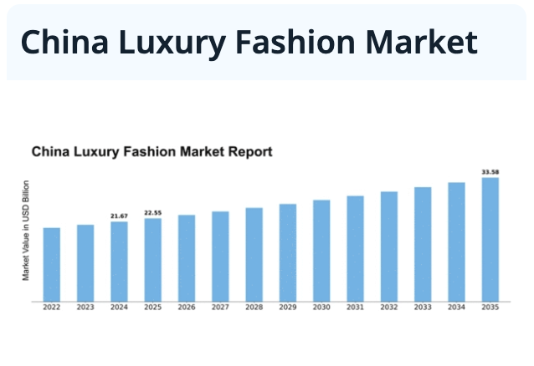
  - In terms of the purchasing behavior and interests, the Chinese luxury consumers tend to be more selective and prioritize items that balance quality, exclusivity, and practicality^{xx}. As shown in the graph below, jewelry and watches continue to dominate the category through 2025. Additionally, casual shoes, handbags, and small leather goods remain popular^{xxiii}. Another trend in the Chinese market includes the growing e-commerce strategies and increase in demand due to cultural influence^{xxi}. Other consumer preferences include high-context communication, colors and symbolism, and collaborations with local brands and celebrities.^{xxiv}.
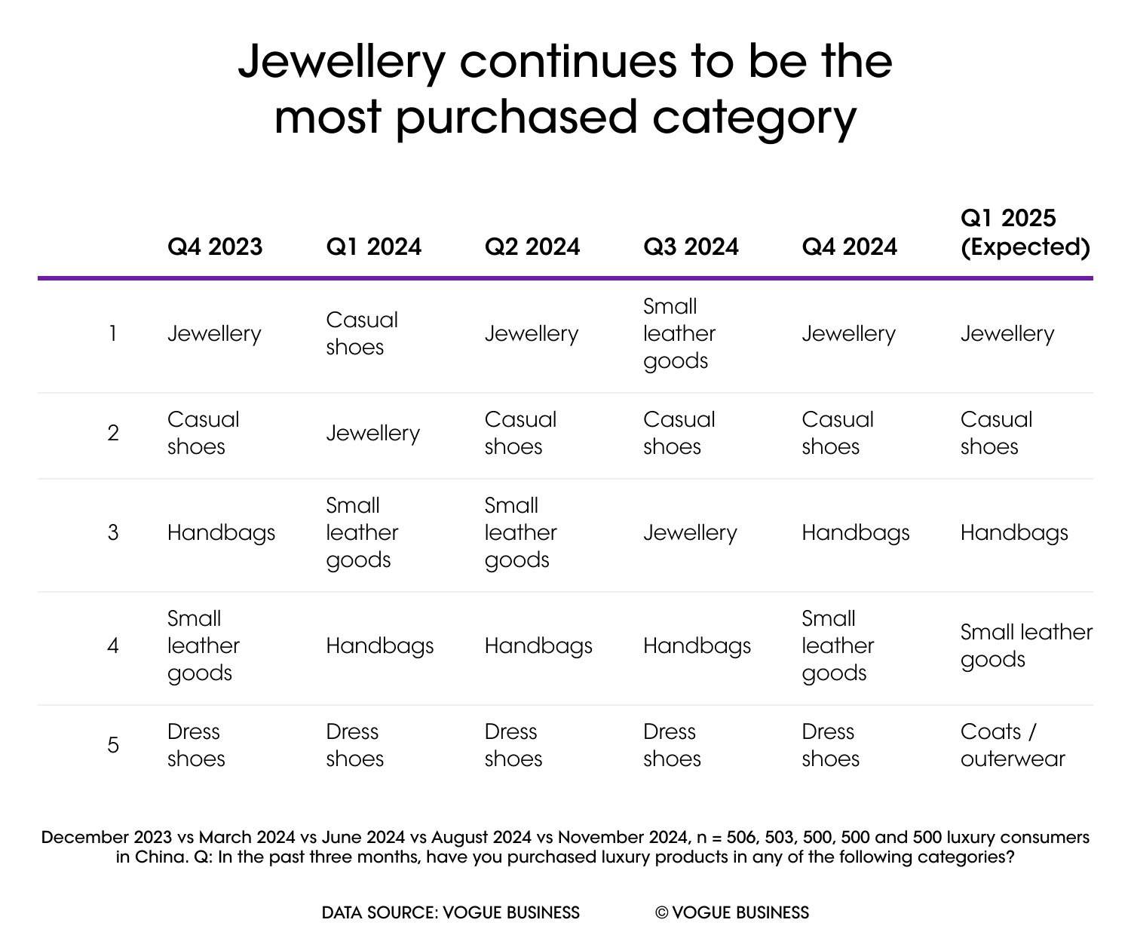
- Standardization & Localization
  - There are two different approaches that luxury brands can take when expanding into a new market. These include standardization and localization. Standardization is when a brand markets the same products worldwide with the same marketing mix and everything. On the other hand, localization is when a brand creates new and unique products for a specific market, with an individualized marketing mix.
  - Many luxury brands tend to opt into localization for a few advantages. First of all, localization allows luxury brands to connect better with different markets. Brands can do this through showcasing cultural awareness and appreciation to better fit cultural values and preferences. Specifically, for China, symbolism and colors heavily influence brand perception, so acknowledging this allows luxury brands to better succeed.
  - On the other hand, localization also has its disadvantages. Some of the messaging and branding may get lost in translation or stray from the core brand identity when creating new products. This expansion can dilute brand recognition and identity. Additionally, localization is more expensive and takes more time to produce.
- Valentino’s Localization Strategy in China
  - Valentino featured an event on Chinese New Year, “Illuminate Your Dream”, which took place in the Tianhou Palace. This event showcased light installations by local Chinese artists^{xxiv}. Valentino focused more on creating a cultural experience that celebrated local Chinese traditions rather than focusing on an event to sell their products. Due to the stronger Chinese consumer value of respecting culture, this campaign helped Valentino build a stronger connection with Chinese consumers.
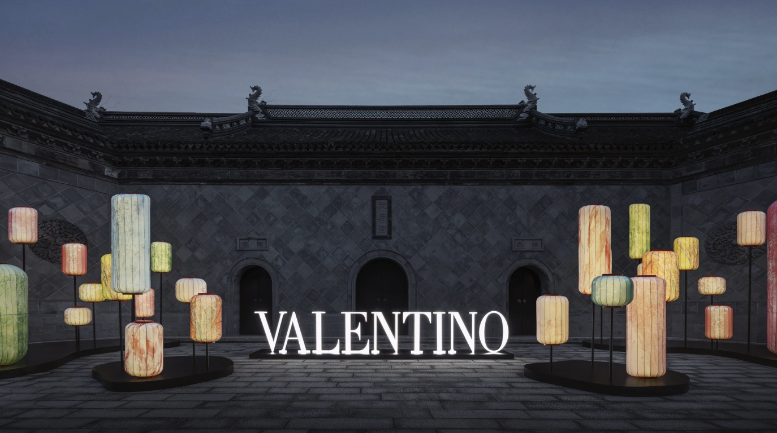
  - Valentino also celebrated Chinese Valentine’s Day, featuring two Chinese celebrities, Ren Min and Ziziao Zhao^{xxv}. Instead of featuring traditional American Valentine colors, they emphasize intimacy, passion, and flower gardens. These symbols and colors better appeal with Chinese audience. This localization strategy adapts its messaging and culture by using local celebrities to appeal to luxury consumers who value cultural relevance.
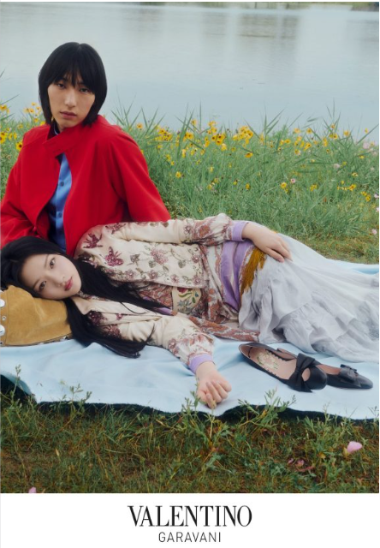
  - Another example of localization is Valentino’s “Her Power” campaign for International Women’s Day. While this is a worldwide celebration, the campaign was celebrated in Shanghai, China featuring women’s creativity through art, music, and literature^{xxvi}. The rise of the "She Economy" is driven by female consumers desire to connect with brands that reflect their values. The marketing event blended Italian aesthetics with local Chinese culture through "urban walks" and experiences through localization efforts. This campaign focuses on the female, millennial consumer by aligning with the values and lifestyle that is often important.
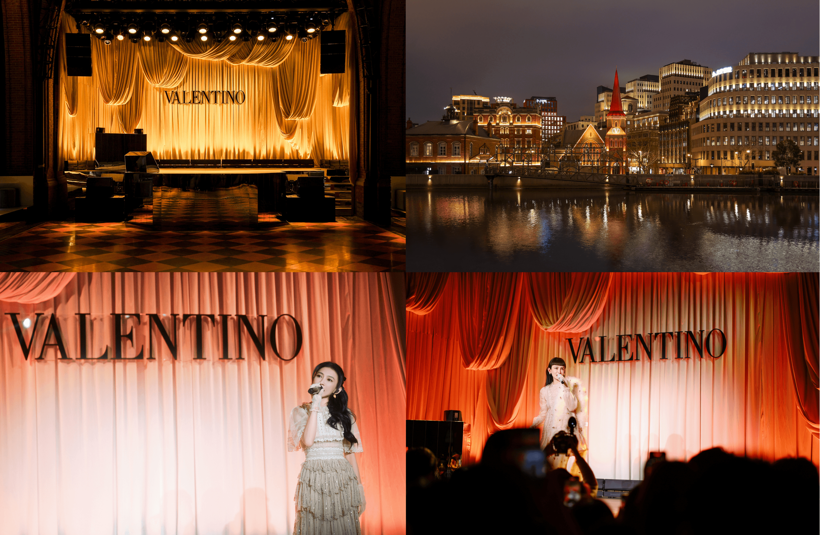
- Brand Identity Prism
- Physique
  - Valentino’s physique is defined by its recognizable physical codes and design elements. One of the most defining features is Valentino Red, which represents boldness, romanticism, and attention-seeking elegance. This expressive and theatrical color has become a defining symbol of the brand. Valentino is also recognized for the Rockstud, a small pyramid stud used on accessories that adds a controlled edge to the brand’s romantic identity. In addition, Valentino uses luxurious fabrics such as tulle, silk, velvet, and lace, reinforcing craftsmanship and femininity.
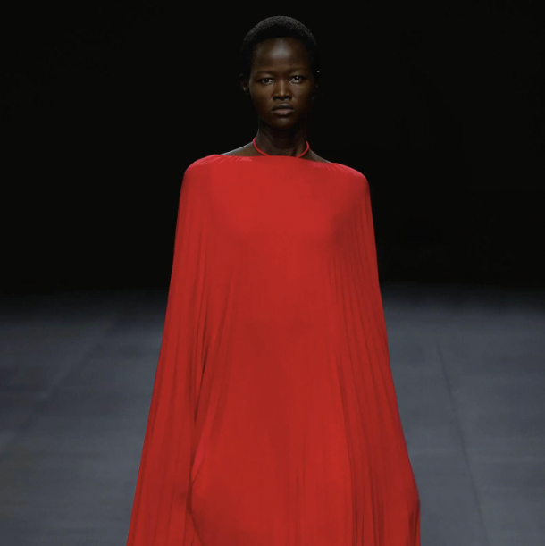
- Relationship
  - Valentino creates a relationship with customers that feels like a friendship built on trust, where the brand understands and reflects the customer’s identity. Valentino also creates a sense of belonging, like being part of a close and stylish friend group. The brand maintains these relationships through strategic partnerships, such as collaborations with Kering Eyewear and Vans, which help Valentino branch into new creative areas while building connections with trusted specialists.
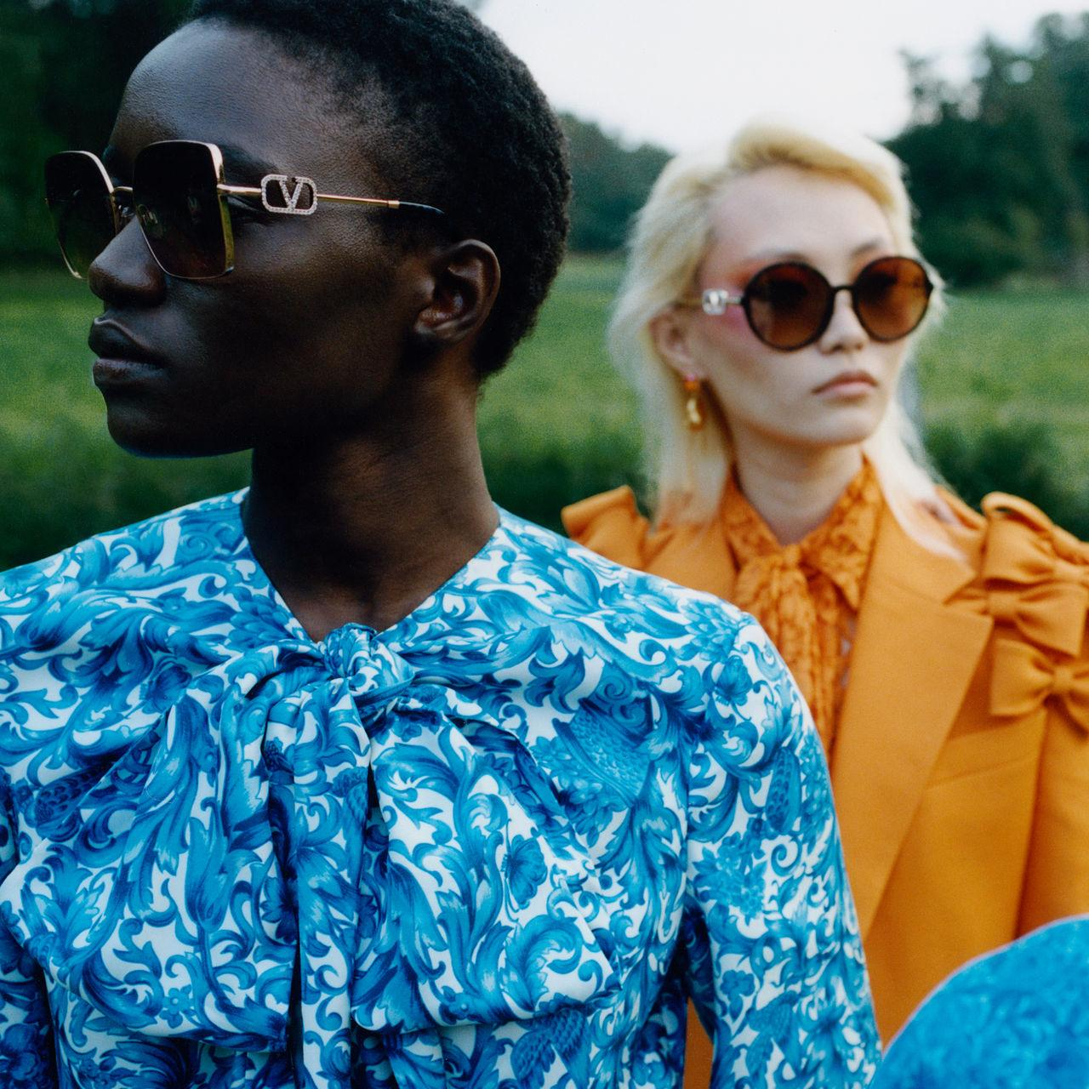
- Reflection
  - Valentino presents an image of romantic elegance, Italian passion, and timeless style. The brand presents itself as refined and artistic, blending traditional fashion with modern feminine silhouettes. Through its collections and campaigns Valentino reflects individuals who value intricate craftsmanship and artistic style.
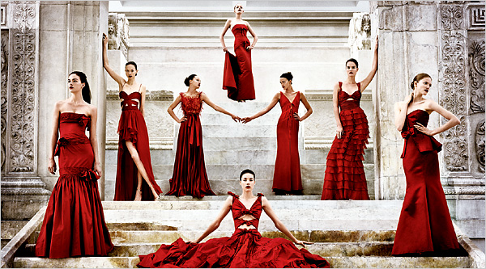
- Personality
  - Valentino’s personality is defined by timeless elegance, romanticism, and sophistication. The brand focuses on graceful and romantic designs that prioritize beauty over trends. The sophisticated brand embodies “Made in Italy” luxury, which blends traditional craftsmanship with modern emotions. Historically, the brand has been associated with “serene happiness”, “warmth”, and an “obsession with detail”, reflecting its commitment to handmade quality^{xxvii}.
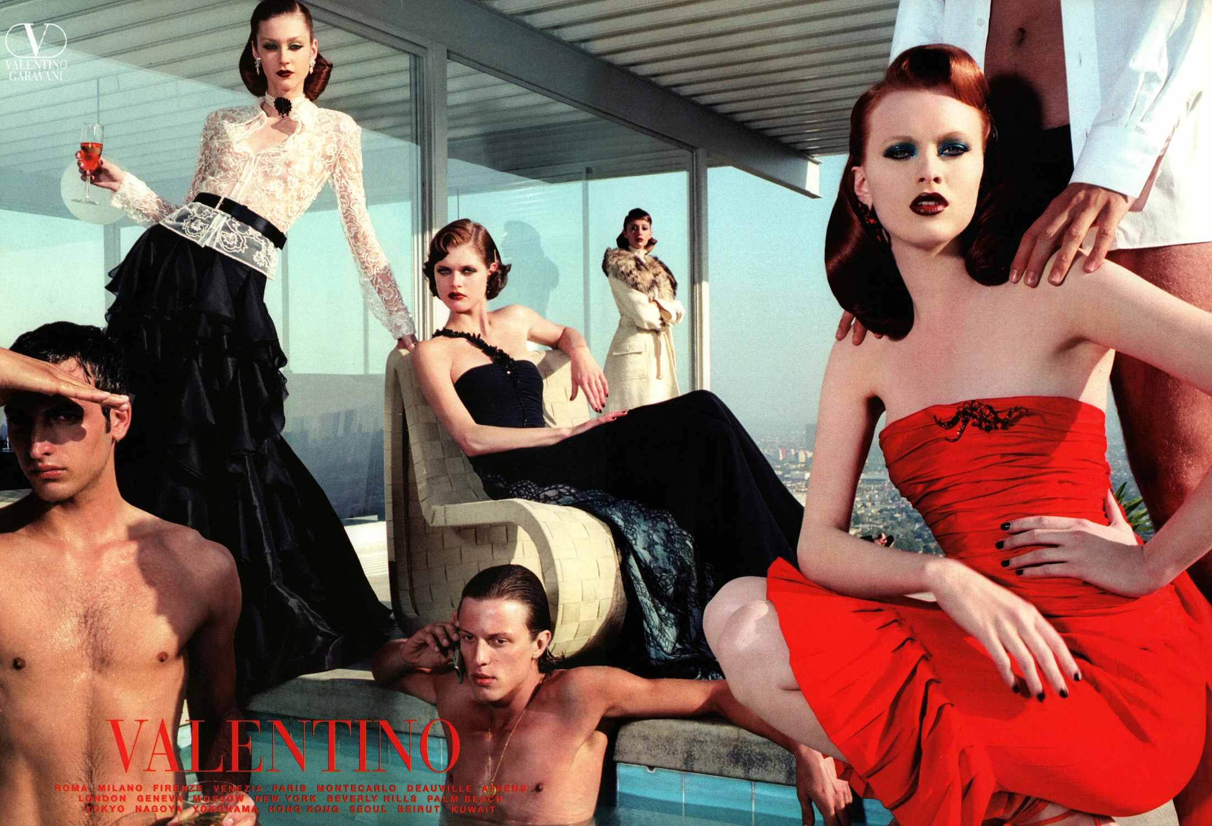
- Culture
  - Valentino’s culture reflects how the brand would live “at home.” The brand lives a romantic and elegant life, while remaining bold and authentic. This lifestyle includes candlelit intimate dinners, close gatherings with friends, and luxurious relaxation such as in-home spa experiences. Campaigns like Valentino Cruise 2026 reflect this elegant yet personal way of living.
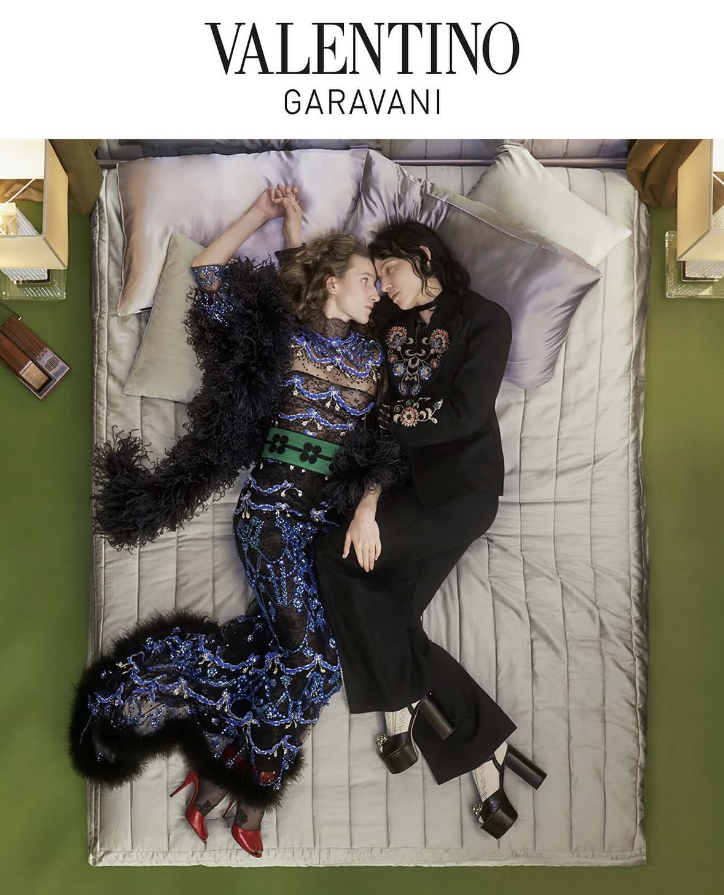
- Self-image
  - Valentino is like a classy friend. They are put together, free-willed, but still collected. This person is always willing to help you explore creative ideas, while staying true to their image. On the weekends, this is the friend that loves relaxing and being carefree. They present a balance of elegance and boldness, enjoying time with others but sticking to what they like and prioritizing feeling themselves. Campaigns such as “The Poetics of Everyday” Fall/Winter 2026 reinforce this idea by showing relaxed models in everyday settings, presenting elegance that feels natural rather than overly posed.
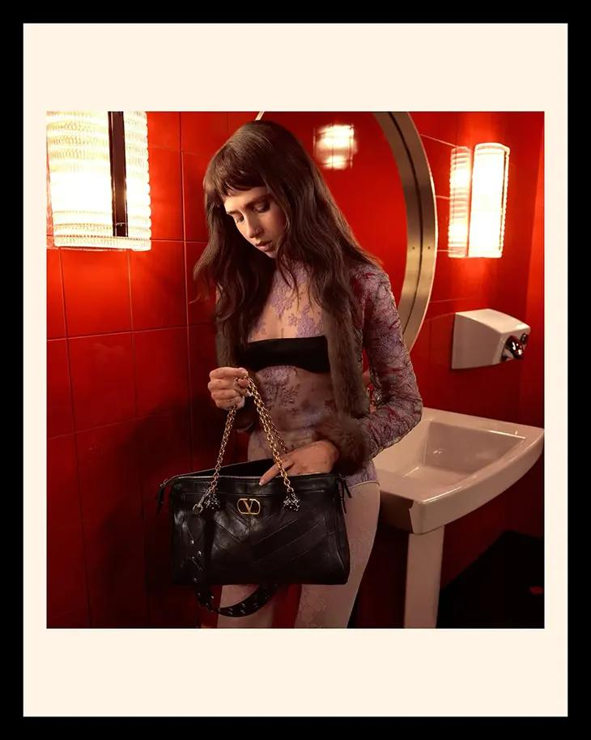

9. Brand Stretching
- Valentino has six different brand extensions ranging from clothing to different types of accessories. These extensions show that the brand is capable of growth into other market segments.
  - The total list of brand extensions is as follows: clothing, shoes, makeup, perfume, eyewear, and accessories such as purses, jewelry, wallets, belts, scarves, and ties. The accessories are by far the biggest category when it comes to brand extensions for Valentino.
- The original purpose of Valentino and what the brand is currently known for is their iconic shade of red. This red came about from the 1959 Spring-Summer collection with the “La Fiesta” dress. This shade of red quickly became a cornerstone of the Valentino brand and every Valentino dress moving forward featured a red dress.
  - While not an extension, this is an example of something that is both symbolic and functional as the color is important to the brand, but the dresses themselves are still considered luxury.
- The first major brand extension Valentino made was in 1978 when their first fragrance Valentino di Valentino was released. Both Valentino himself and Giancarlo Giammetti invited many well-known and influential people to the Théâtre des Champs-Elysées for a performance by Roland Petit’s ballet starring Mikhail Baryshnikov, and gave away about 1,000 bottles of that first fragrance, Valentino di Valentino, to the crowd.
  - This product expansion was seen as symbolic, as the perfume reflects the brand’s identity of elegance, femininity, and sophistication.
  - Being a symbolic extension, the marketing for the perfume focuses more on the brand’s core values, personality, and prestige as well as a deep emotional connection with consumers. While Valentino may not be the technical expert when it comes to perfume, symbolic extensions are still a great way to attract customers.
- The next major brand extension was the denim line, Valentino Viva, launched in New York in 1979. While this isn’t always the first thing people think of when it comes to Valentino, the line still holds a very important place in Valentino’s history.
  - This product extension is seen as functional, as even though jeans are seen as a more casual style of clothing, clothing traditionally is still where Valentino’s expertise lies.
  - Being a functional extension, this product more aligns with the technical expertise and benefits of the brand when trying to segue into a different branch of the market. This is very functional for Valentino as their expertise is found in clothing items.
- One of the newest expansions coming from Valentino is their Kering Eyewear coming in spring/summer 2026. The collection itself debuted at Paris Fashion Week and is considered a brand extension upgrade.
  - This is not the first time Valentino has expanded into eyewear. The brand first extended into eyewear in the 1990s and is the most recent product extension from Valentino.
  - This extension is also seen as functional as this collection is adding substantial value to the extension category, expands into a product that has new purpose, as well as expanding into new distribution channels.
10. Conclusion
- Given what Valentino is currently doing in the market, I believe that they are living up to the necessary criteria to still be considered a luxury brand based on what we have been learning so far this semester. There are few, if any, areas where Valentino is struggling or could vastly improve itself.
- One area I believe Valentino is excelling in is brand identity. The brand is keeping true to its core values across all channels. Valentino is known for having a very romantic and elegant image, and that is widely shown in the brand’s personality.
  - This idea of elegance, timelessness, and romanticism can also be found across the brand itself, but most notably in the brand’s culture and self-image. Brand identity is incredibly important if a luxury brand wants to thrive and survive, so having such a strong brand identity that it doesn’t get lost anywhere is both incredibly important and valued.
  - I believe this is an example of brand excellence due to the consistency of the brand image across different channels and marketing segments found within Valentino. I also think Valentino finds success here because they continue to stay true to their roots and each creative director that has come in wants to continue the legacy of Valentino Garavani.
- Another area that I believe Valentino is excelling in is localization, specifically within China. Recently Valentino has held many different events that heavily relate into Chinese culture that allows China to shine, while still adhering to the brand’s core values and principles.
  - I believe this is an aera of excellence because it shows that Valentino is willing to appeal to different markets in different parts of the world instead of having one overall campaign and trying to get different countries to conform to it. Along with that, it shows that Valentino values its customers in different countries and is willing to put in the effort to market to specific groups of people.
  - Localization shows cultural awareness and appreciation for different cultures outside of the brand’s own, and this is important because it ensures that the brand will be perceived correctly by different customer groups. Being respectful and appreciative of another country’s culture when marketing towards them will ensure that a bran will succeed, and this is one of the main reasons why I think Valentino does such a great job with localization.
- One area that I believe is of concern for Valentino is anti-laws. While the brand sticks to and follows many different anti-laws, they aren’t flawless. A notable anti-law that Valentino breaks is #16 “Keep Stars Out of Advertising.” When highlighting and placing celebrities in the middle of a campaign, it signals to consumers that the brand itself needs to latch onto the status and fame of a celebrity to keep the brand alive.
  - While it may be appealing to use a celebrity in a campaign, this starts to muddle the relationship brands can have with consumers and is something that should never really be focused on.
  - Even though many of the anti-laws highlighted earlier are ones that Valentino does follow, I would suggest that the brand re-evaluate itself, especially when it comes to using celebrities in their campaigns.
- Another area of concern is for Valentino is brand stretching. Valentino has stretched itself across many different marketing segments, and one could argue that it’s too many. Outside of the fashion it is known for, Valentino has stretched itself across six different market segments with varying degrees of success.
  - Most of the extensions Valentino has created are only symbolic in nature, and don’t really add much value or significance to the Valentino name. This shows that Valentino is not the technical expert in these different marketing segments like other luxury brands may be.
  - My suggestion for Valentino is to eliminate the marketing segments that are not working for the brand. The only positive here is that the brand has not stretched itself since the 1990s, as there really is no other place for the brand to stretch into. By cutting down on extensions, Valentino can really focus on the brand’s core values and emphasize them more in their more mainstream products.

https://www.valentino.com/en-us/v-universe/maison/history
https://theconversation.com/valentino-shaped-the-runway-and-the-red-carpet-for-60-years-273891
https://www.harpersbazaar.com.sg/fashion/news-trends/valentino-garavani-greatest-moments
https://www.nytimes.com/2024/03/22/fashion/valentino-creative-director-pierpaolo-piccioli.html#:~:text=Though%20it%20had%20often%20been,he%20said%20before%20the%20show.
https://wwd.com/business-news/retail/valentino-flagship-renovated-reopens-milan-1238114154/#:~:text=September%205%2C%202025%2C%205:,artisanal%20sculptured%20chandeliers%20in%20cotton.
https://www.magazzino.art/about/news/time-out-look-inside-the-beautiful-new-valentino-flagship-store-on-madison#:~:text=%E2%80%94%20and%20it%20looks%20as%20beautiful,Spring%20Museum%20Magazzino%20Italian%20Art.
https://www.highsnobiety.com/p/valentino-anatomy-of-dreams-fragrance/
https://logoheritage.com/valentino-logo-history-meaning-symbolism-brand-heritage/
https://graziamagazine.com/articles/valentino-i-mean-its-rockstud/
https://1000logos.net/red-valentino-logo/
https://en.wikipedia.org/wiki/Anish_Kapoor https://www.lissongallery.com/news/orizzonti-rosso-featuring-anish-kapoor-at-palazzo-mignanelli-23-rome-italy
https://hypebeast.com/2020/3/valentino-crossbody-roger-dean-red-dragon https://tradingboundariesfineart.com/news/3-valentino-roger-dean-collaboration-spring-summer-2020/
https://www.russh.com/chloe-leong-valentino-lecole-sydney/ https://harpersbazaar.com.au/vanentino-lecole-skin-deep/ https://www.chloeleong.com.au/
https://www.artnet.com/artists/mario-schifano/ https://news.artnet.com/art-world/valentino-magazzino-mario-schifano-2394885 https://www.magazzino.art/visit/exhibitions/mario-schifano-the-rise-of-the-60s
https://www.noiregallery.com/artist/giorgio-di-salvo/
https://www.luxurydaily.com/valentino-garavani-and-vans-present-ai-generated-campaign/
https://www.harpersbazaar.com/fashion/designers/a69291435/the-week-in-fashion-valentino-tate-mcrae-dakota-johnson-campaign/
https://www.businessoffashion.com/news/luxury/valentino-returns-to-profitability-sales-grow-above-2019/
https://fashionunited.com/news/fashion/a-valentino-factory-is-ravaged-by-flames-destroying-38-000-pairs-of-shoes/2021041239363
https://vmagazine.com/article/valentino-releases-a-cinematic-and-candid-campaign-for-pre-fall-2025/
https://www.fashiontimes.com/valentino-resort-2025-campaign-12183
https://www.highsnobiety.com/p/alessandro-michele-valentino-campaign-avant-les-debuts/
https://www.instagram.com/reel/DUfmJIHCF1g/
https://www.instagram.com/p/DPbik50CBHX/?hl=en
https://www.youtube.com/watch?v=hAnnMUS5YSY
https://glamobserver.com/the-history-and-evolution-of-valentino/#:~:text=Valentino%20Red%20Dress,red%2C%E2%80%9D%20he%20told%20Vogue.%E2%80%8B
https://wwd.com/beauty-industry-news/fragrance/feature/valentinos-fragrance-story-6405135-506087/#:~:text=The%20house's%20first%20foray%20into,back%20to%20the%20late%20Seventies.&text=When%20Valentino%20signed%20a%20fragrance,di%20Valentino%2C%20to%20the%20crowd%20%20%E2%80%8B
https://wwd.com/beauty-industry-news/fragrance/feature/valentinos-fragrance-story-6405135-506087/#:~:text=The%20house's%20first%20foray%20into,back%20to%20the%20late%20Seventies.&text=When%20Valentino%20signed%20a%20fragrance,di%20Valentino%2C%20to%20the%20crowd%20%20%E2%80%8B
https://glamobserver.com/the-history-and-evolution-of-valentino/#:~:text=Valentino%20Red%20Dress,red%2C%E2%80%9D%20he%20told%20Vogue.%E2%80%8B
https://www.keringeyewear.com/newsroom/2025/Kering-Eyewear-and-Valentino-announce-global-partnership-agreement ^{xix}https://www.mckinsey.com/capabilities/growth-marketing-and-sales/our-insights/chinese-luxury-consumers-more-global-more-demanding-still-spending ^{xx} https://mdr-i.com/2025-mid-year-china-luxury-consumer-sentiment-towards-luxury-purchase-is-cautious-relative-to-a-renewed-optimism-in-hong-kong/ ^{xxi} https://www.marketresearchfuture.com/reports/china-luxury-fashion-market-46369 ^{xxii} https://marketingtochina.com/china-luxury-market-guide/ ^{xxiii} https://www.vogue.com/article/consumer-whiplash-in-china-continues-to-challenge-luxury https://marketingtochina.com/understanding-chinese-consumer-behavior-a-cultural-perspective/ ^{xxiv} https://jingdaily.com/posts/how-valentino-built-emotional-capital-through-a-lantern-fair ^{xxv} https://theimpression.com/valentino-chinese-valentines-day-2025-ad-campaign-review/ ^{xxvi} https://daoinsights.com/exclusives/going-highbrow-the-cultural-campaigns-of-international-womens-180bookshop ^{xxvii} https://ottodisanpietro.com/blogs/editorial/valentino-the-legacy-of-the-great#:~:text=Valentino%20Garavani%20built%20an%20entire,his%20emblem%20to%20this%20day

